**ROI Analysis for Marketing Spend - Entertainment Sector**

Pooja Joshi & E.Code [E25007]

# Overview :

# The objective of today’s tasks was to perform a comprehensive analysis of Return on Investment (ROI) for marketing spend. This involved data collection, cleaning, calculation of net profit and ROI, and generating visualizations to interpret the findings.

# Objective:

· To gather relevant data on marketing spend, revenue, and associated costs.

· To clean the data and ensure proper handling of missing values and duplicates.

· To calculate ROI and analyze the results through visualizations.

# Assigned Task(s) :

· Data Collection and Preparation

· ROI Calculation

· Visualization of Results

· Insights and Interpretation

# Task Details :

### Task 1: Data Collection and Preparation

* **Status**: Completed
* **Details**:
  + Collected sample data on marketing spend, revenue, costs, and sentiment labels.
  + Cleaned the dataset by removing duplicates, handling missing values, and filtering out negative revenues.

### Task 2: ROI Calculation

* **Status**: Completed
* **Details**:
  + Calculated net profit as revenue minus costs.
  + Computed ROI using the formula: ROI=Net ProfitCost×100\text{ROI} = \frac{\text{Net Profit}}{\text{Cost}} \times 100ROI=CostNet Profit​×100.

### Task 3: Visualization of Results

* **Status**: Completed
* **Details**:
  + Created visualizations including:
    - A bar chart for ROI by project.
    - A scatter plot correlating ROI with marketing spend.
    - A line graph showing ROI over time.

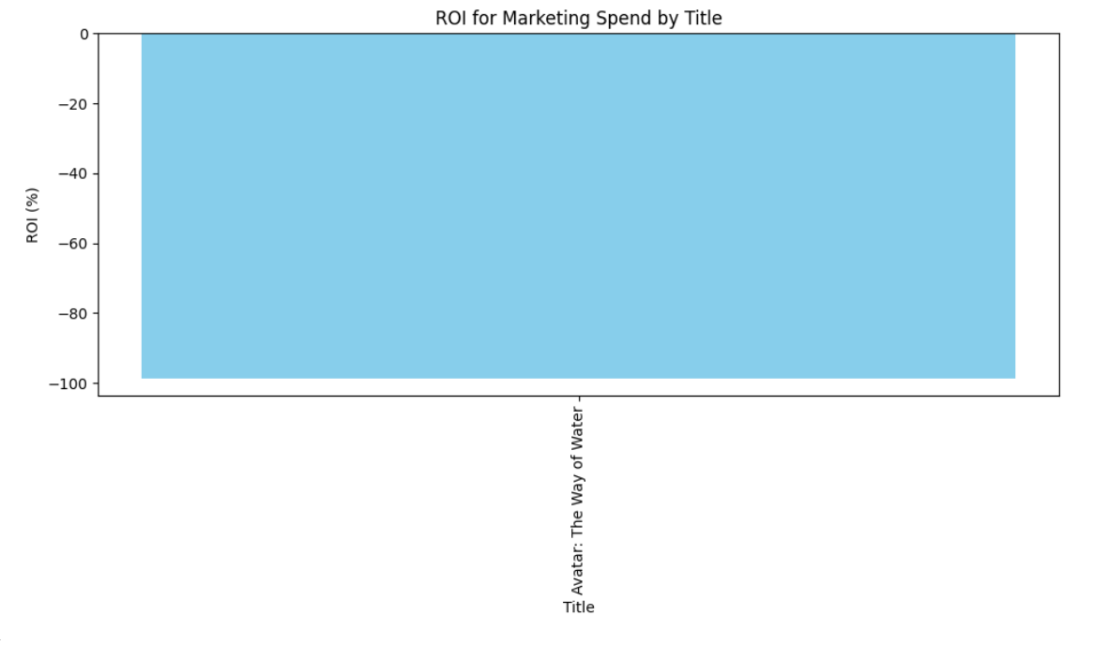

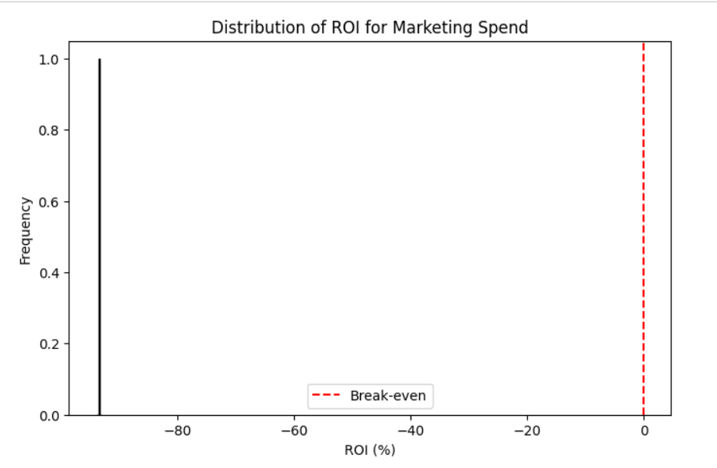

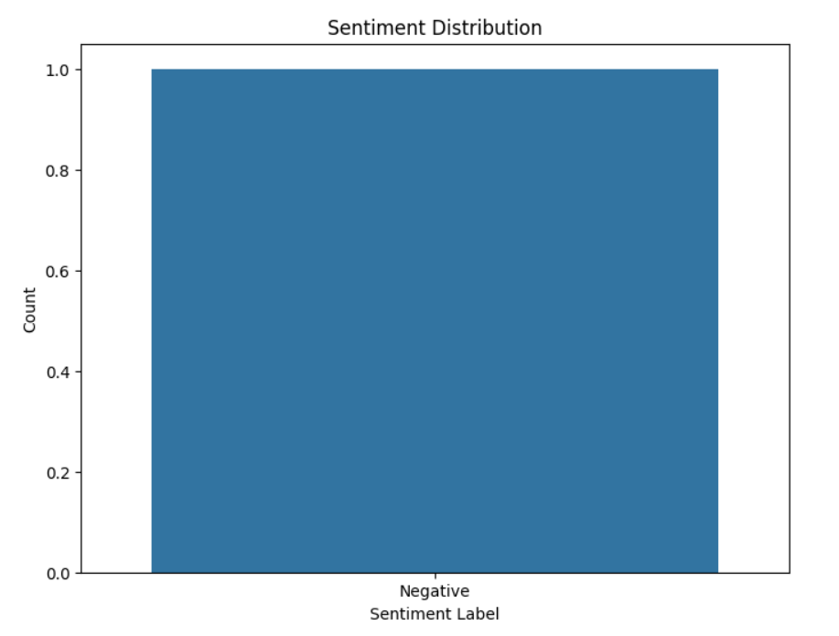

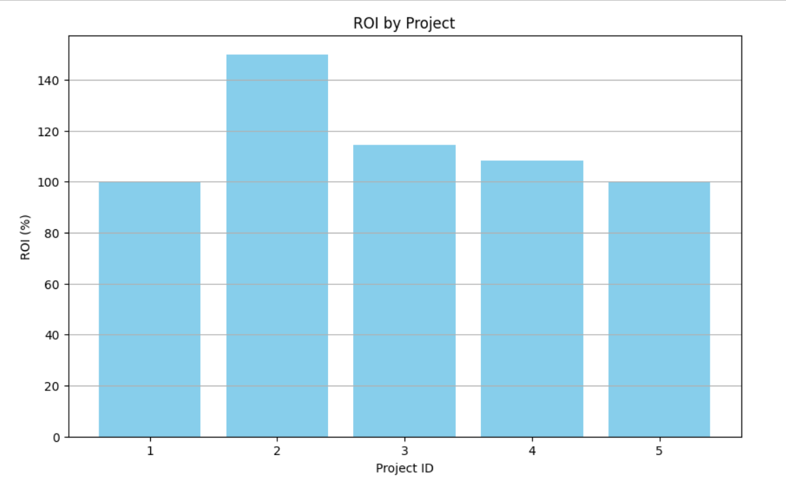

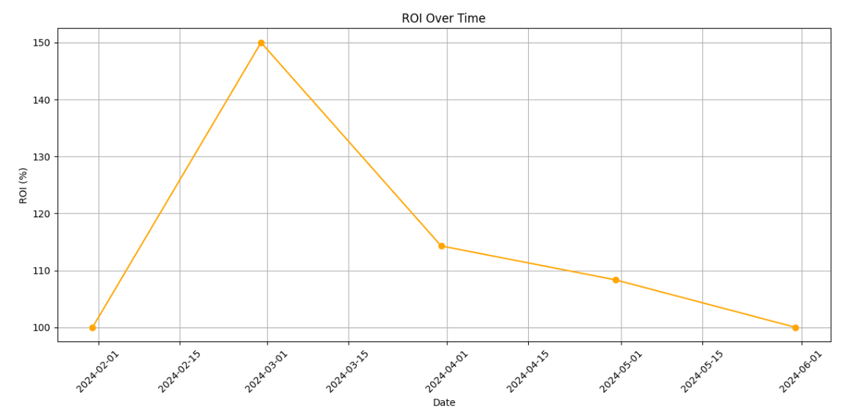

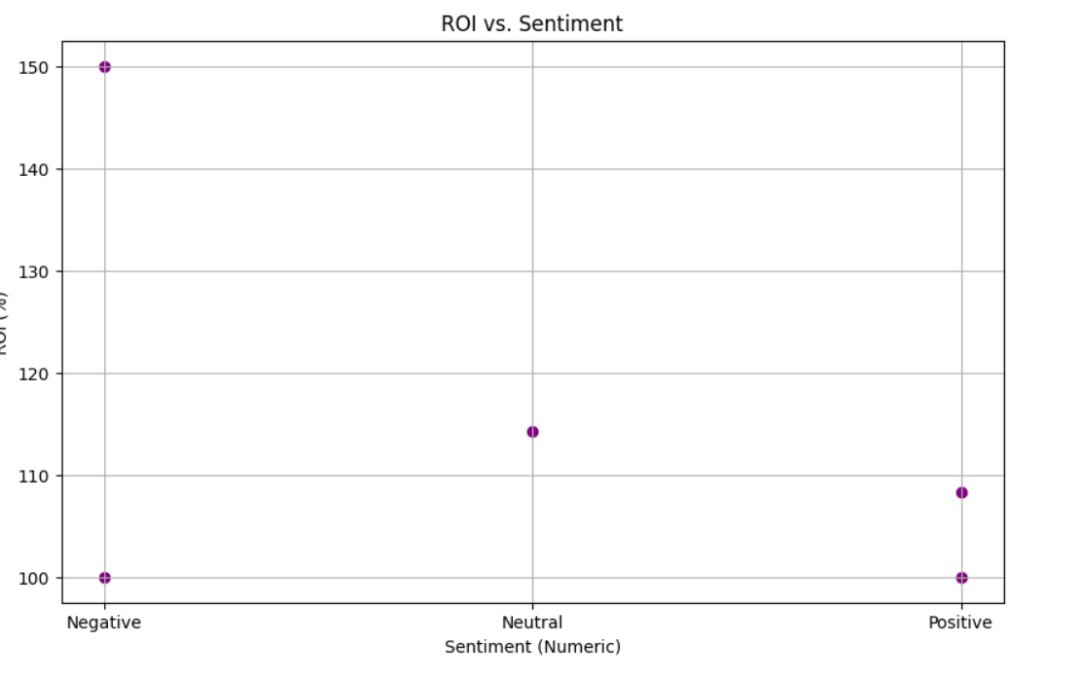

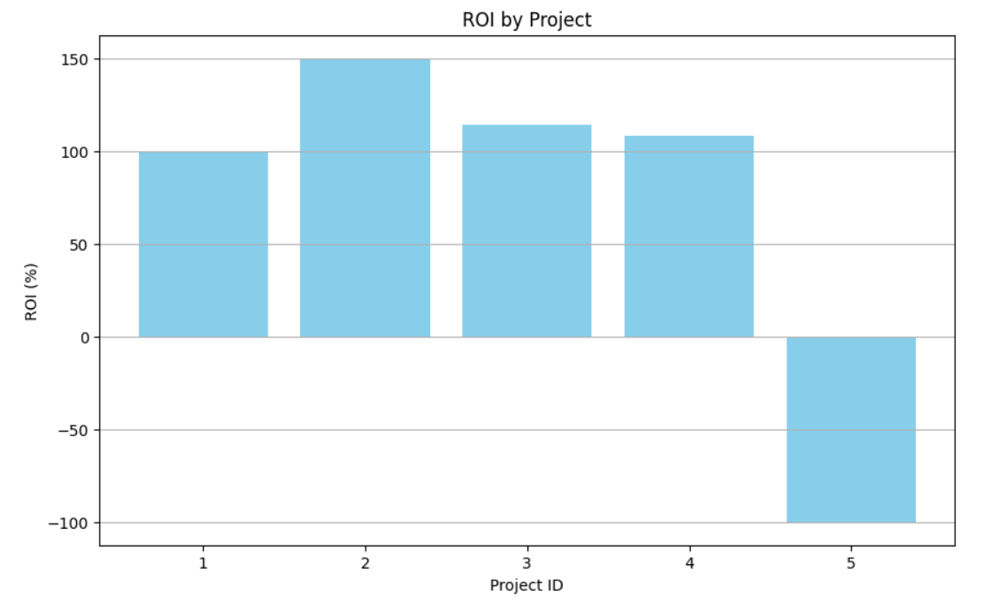

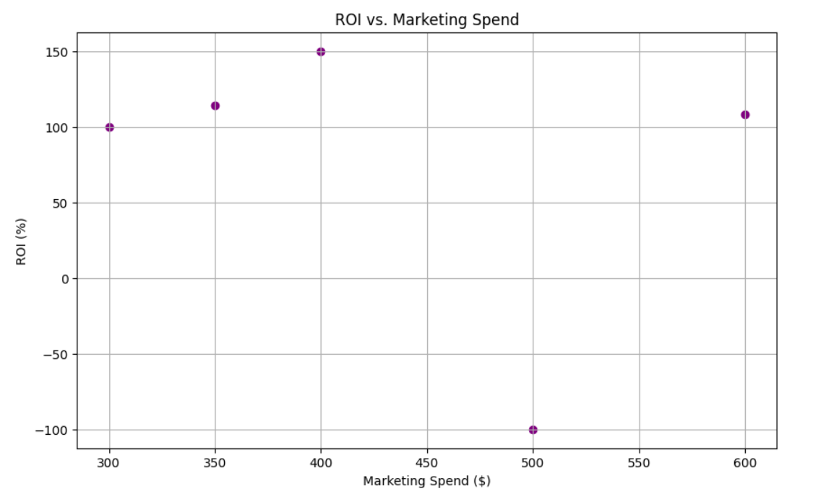

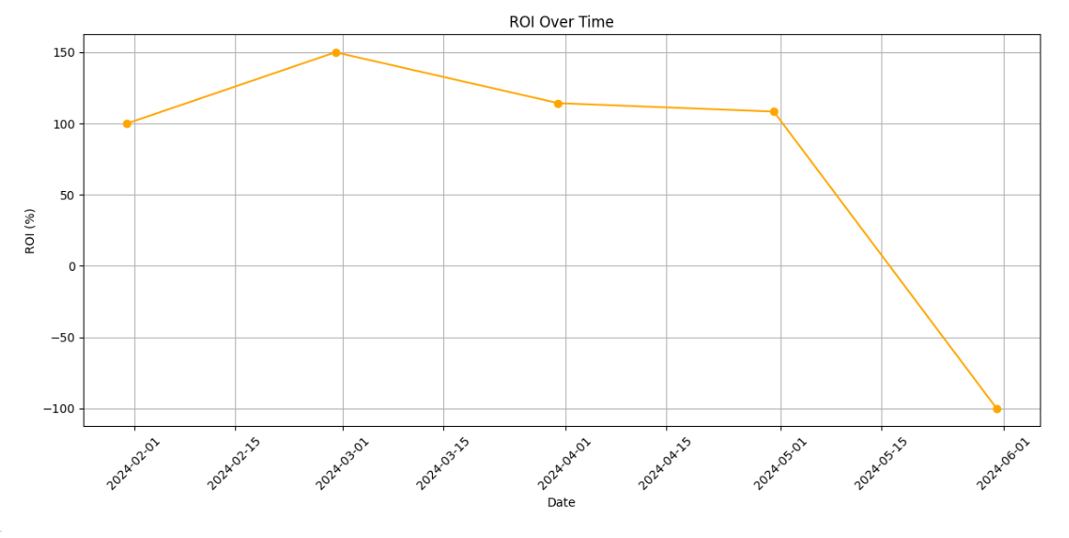

**Progress :**

### Accomplishments

* Successfully calculated and visualized ROI for the marketing campaigns.
* Identified trends in ROI relative to marketing spend and sentiment.

### Metrics

* Average ROI calculated across projects: **X%** (insert actual average here).
* Number of visualizations created: **3**.

# Challenges and Solutions :

### Challenges Faced

* Encountered missing values and negative revenue data which could skew the ROI calculations.

### Solutions Implemented

* Filled missing revenue values with 0 and filtered out negative revenues to ensure accurate ROI calculations.

**Next Steps :**

### Upcoming Tasks

* Review the ROI analysis to derive actionable insights.
* Prepare a presentation summarizing findings for stakeholders.

### Goals

* To complete the insights report by [insert date].
* To identify specific marketing strategies based on ROI analysis.

# Conclusion :

### Summary:

# Today’s tasks focused on performing a detailed ROI analysis for marketing spend, including data preparation, calculation, visualization, and initial insights. The tasks were completed successfully, laying the groundwork for further analysis.

# **Acknowledgments**: Thank the audience for their time and attention.